ASSIGNMENT NO 4

Nirbhay Ahir

[Nirbhay.ahir36@gmail.com](mailto:Nirbhay.ahir36@gmail.com)

1. What exactly is []?

Ans: Square brackets in python are used to denote a list.

[] means an empty list with no elements in it.

2. In a list of values stored in a variable called spam, how would you assign the value 'hello' as the third value? (Assume [2, 4, 6, 8, 10] are in spam.)

Ans: We can simply do this by assigning the third element of the list a value “hello” as follows :

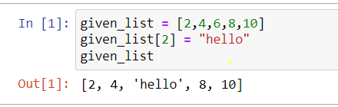

Let's pretend the spam includes the list ['a', 'b', 'c', 'd'] for the next three queries.

3. What is the value of spam[int(int('3' * 2) / 11)]?

Ans: spam[int(int('3' * 2) / 11)] is same as spam[int(33/11)] = spam[3] which will give the fourth element in the list which is ‘d’

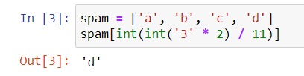

4. What is the value of spam[-1]?

Ans: spam[-1] will give the last element of the list which is ‘d’

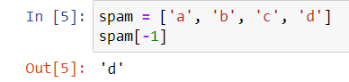

5. What is the value of spam[:2]?

Ans: spam[:2] returns all elements in the list spam from 0 to 2 excluding 2.

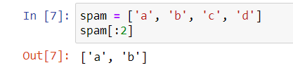

Let's pretend bacon has the list [3.14, 'cat,' 11, 'cat,' True] for the next three questions.

6. What is the value of bacon.index('cat')?

Ans: The value of bacon.index('cat') is 1 as it will return the very first occurrence of element ‘cat’ and its index is 1.

7. How does bacon.append(99) change the look of the list value in bacon?

Ans: bacon.append(99) will add the element 99 at the end of the list and the new list bacon will be

[3.14, 'cat', 11, 'cat', True, 99]

8. How does bacon.remove('cat') change the look of the list in bacon?

Ans: bacon.remove('cat') will remove the first occurrence of element ‘cat’ inside the list and the new list will be [3.14, 11, 'cat', True]

9. What are the list concatenation and list replication operators?

Ans: **‘+’** is a list concatenation operator

and **‘*’** is a list replication operator.

10. What is difference between the list methods append() and insert()?

Ans: append() add a new element to the end of the existing list while insert() add a element to a specific index which we have to pass inside it.

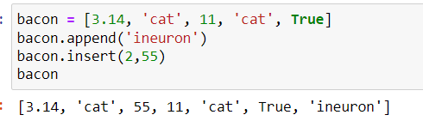

11. What are the two methods for removing items from a list?

Ans: The two methods for removing items from a list are as follows

del statement – we have to pass index of the element inside it.

remove() – we have to pass the element inside it.

12. Describe how list values and string values are identical.

Ans: Here are the few reasons why list values and string values are identical

1. Both lists and strings can be passed to len() function
2. Both have indexes and slices, be used in for loops,
3. Both can be concatenated or replicated
4. Both can be used with the in and not in operators.

13. What's the difference between tuples and lists?

Ans: Tuples are immutable and they cannot be changed at all. They are written using parentheses ().

Lists are mutable and they can add, remove or change values. They are written using square brackets [].

Common thing between them is both can be sliced on indexed.

14. How do you type a tuple value that only contains the integer 42?

Ans: tup = (42,)

The trailing comma is necessary inside it otherwise it will be considered as a int type.

15. How do you get a list value's tuple form? How do you get a tuple value's list form?

Ans: The tuple() and list() functions, respectively are used to convert a list to tuple and vice versa.

16. Variables that "contain" list values are not necessarily lists themselves. Instead, what do they contain?

Ans: They contain the references to the list values.

17. How do you distinguish between copy.copy() and copy.deepcopy()?

Ans: The copy.copy() function will do a shallow copy of a list.

The copy.deepcopy() function will do a deep copy of a list.

To be more precise in a single dimensional list shallow and deep copy works the same.

But inside a nested list shallow copy is not same as deep copy as in deep copy different memory locations are allocated.

